American Association of University Women Flower Sale
In Support of Graduate Women’s Scholarship

Buyer Name Buyer Email

Contact #
** Make checks payable to Loveland AAUW (due at time of order)

Orders due March 29th --- to Linda Espanol at: lyndaesp@gmail.com - 970-290-4444
or Teri Smith at: 3007 Douglas Ave., Loveland, 80538 – 405-820-4600

Plantorium Geraniums (Sun)
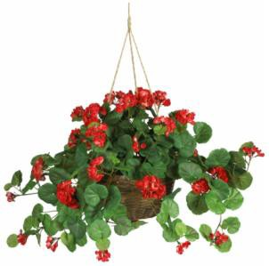
Baskets - $38.00 ea.
Pink
Red
Salmon
White

Gal. - $12.00 ea.
Pink
Red
Salmon
White

Qt. - $9.00 ea.
Pink
Red
Salmon
White
Plantorium Begonias (Shade)

Quart - $9.00 ea.

Red
Yellow
Rose Petticoat (pink&white)
Orange
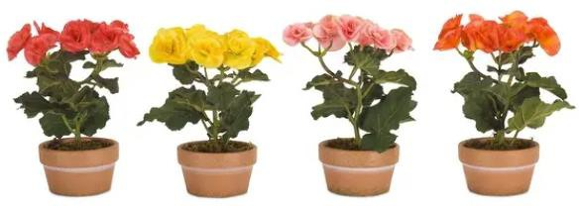

AAUW Seller: Pickup Name:
TOTAL Number of PLANTS

TOTAL Cost of PLANTS $

PICK UP INFORMATION: Saturday, May 7th 9:00AM - 12:00PM @ 1431 Allison Dr. Loveland For questions please contact Linda @ 970-290-4444 or your AAUW seller

SUGGESTION: Please make a copy or take a photo of your order for your records.

